INTEL® UNNATI GRAND CHALLLENGE SUMMER'23

## **ANALYSING ADAS ALERT DATA FOR IMPROVED ROAD SAFETY**

TEAM: KREVENTROZ

TEAM MEMBERS:

1. KRISHNA KANTH
2. MOHAMED SHAFEEQ I
3. KAMAL D

COLLEGE NAME: RAJALAKSHMI INSTITUTE OF TECHNOLOGY, CHENNAI

DATE OF SUBMISSION: 10. Sep.2023

**ABSTRACT:**

Advanced Driver Assistance Systems (ADAS) are essential for boosting road safety in a time of quickly changing automobile technology. Through a variety of sensors and alarm mechanisms, these systems produce a plethora of data, providing a priceless chance to learn about driving habits and potential dangers. This research attempts to retrieve, analyse, and draw useful insights from three months of ADAS warning data, concentrating on longitude, latitude, vehicle speed, date, and time. We aim to provide a thorough understanding of driving behaviour, discover patterns, and eventually improve traffic safety by utilising analytical tools and approaches.

**INTRODUCTION:**

The analysis of Advanced Driver Assistance Systems (ADAS) warning data is at the forefront of innovation in the automobile sector at a time when data is increasingly recognised as a potent instrument for improving safety and efficiency. The goal of this project is to analyse and comprehend the startling 21,326 rows of alert data that make up the rich tapestry of safety-critical data generated from five different cars. This project's core involves the methodical examination of latitude, longitude, and date characteristics to determine not only when and where these warnings occurred but also their underlying causes**.**

The use of ADAS technologies in cars is increasing, and their capacity to gather and transmit real-time data is revolutionising our understanding of driver behaviour, traffic conditions, and vehicle safety. The goal of this study is to better understand the dynamics of ADAS warnings by utilising the power of this data. By doing this, we hope to make driving safer and more knowledgeable for all motorists.

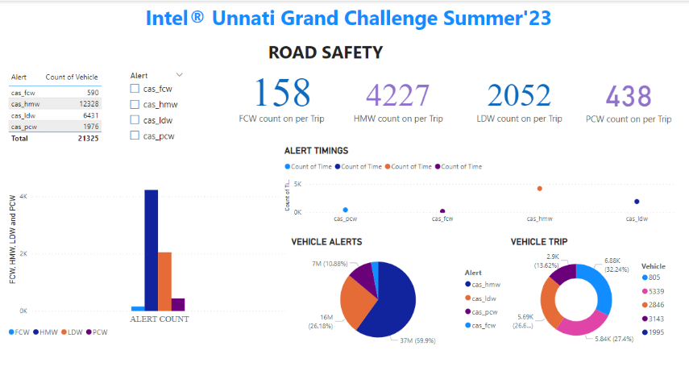

**DESCRIPTIVE ANALYSIS:**

The descriptive statistics analysis provides valuable insights into the driving behaviour and alert distribution within the dataset. The mean speed of all vehicles is calculated at 39 km/h, indicating the average speed across the dataset. However, individual vehicle speeds reveal variations: vehicle 805 maintains an average speed of 37.93 km/h, while vehicles 1995, 2846, 3143, and 5339 exhibit speeds of 25.94 km/h, 43.15 km/h, 37.67 km/h, and 34.93 km/h respectively. In terms of percentile information, it is evident that 25% of the alerts occur when speeds are below 27 km/h, while 50% of alerts are triggered when speeds fall under 41 km/h. A higher percentile, 75%, is marked at 54 km/h, signifying the speed below which 75% of alerts are observed. The dataset encompasses locations primarily centred around the NH32 and SH114 highways, connecting significant areas in Chennai like Acharapakkam, Melmaruvathur, Vandalur, Tambaram, and extending towards Ennore. These locations form a diverse geographic spread, reflecting driving patterns across urban and suburban regions. Additionally, the identification of black spots based on locations indicates regions with the highest alert occurrences. This understanding can be pivotal in targeting interventions, road improvements, and safety campaigns to address driving challenges and enhance overall road safety in these areas.

**SPATIAL INSIGHTS:**

**Lane Departure Warning (LDW) Alerts**

The analysis of Lane Departure Warning (LDW) alerts has unearthed significant insights into the spatial patterns and underlying reasons for these alerts. LDW alerts serve as a critical component of Advanced Driver Assistance Systems (ADAS), designed to enhance road safety by warning drivers when their vehicle drifts out of its lane without proper signalling. Here, we delve deeper into LDW alerts, highlighting their importance and the factors that contribute to their occurrence.

**Spatial Patterns and Insights**

One of the most striking findings of our analysis is the concentration of LDW alerts at specific geographical locations. These alerts frequently manifest at intersections where service roads intersect with highways, on streets connecting to main roads, and notably, at the entrances and exits of bridges. To illustrate, consider the following example:

Example 1: The intersection of "Grand Truck Road with Outer Ring Road" in Chennai is a prime instance. This intersection is renowned for its complexity and high traffic volume. LDW alerts occur here regularly due to the intricate road layout, multiple merging lanes, and the need for precise lane-keeping in congested conditions.

Example 2: Another hotspot for LDW alerts is the "Grand Truck Road with Tambaram Bypass." This location, too, witnesses a notable frequency of LDW alerts. The complex geometry of the intersection, combined with a high influx of vehicles, often results in lane departure incidents.

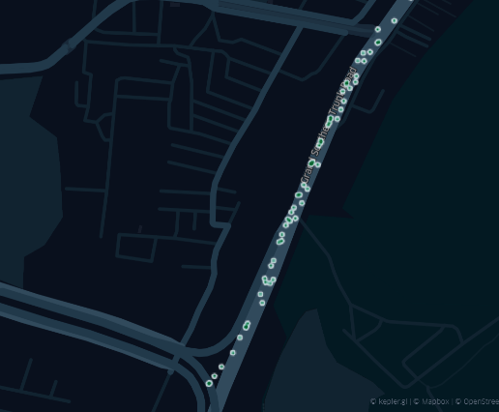 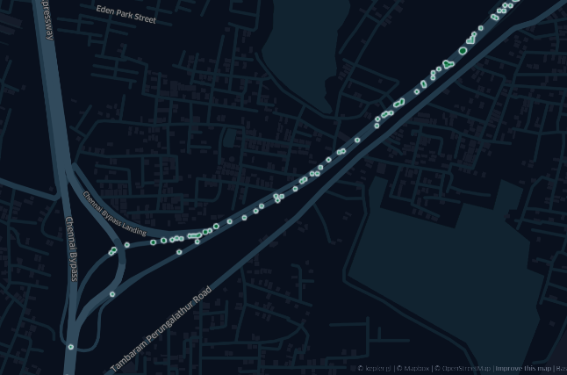

(a). Grand Truck Road with Outer Ring Road (b). Grand Truck Road with Tambaram Bypass

**Factors Contributing to LDW Alerts**

Beyond specific geographical patterns, LDW alerts can be triggered by several factors:

1. Distracted Driving: Inattentive or distracted drivers may inadvertently drift out of their lanes. LDW alerts are crucial in such cases to refocus the driver's attention on the road.
2. Heavy Traffic: Congested traffic conditions may require constant lane changes, increasing the chances of unintentional lane departures.
3. Road Complexity: Complex Road layouts, intersections, and bridges can be challenging for drivers to navigate, increasing the likelihood of lane departures.

**Pedestrian Collision Warning (PCW) Alerts:**

Our analysis of Pedestrian Collision Warning (PCW) alerts has yielded valuable insights into both their spatial distribution and the contextual factors driving these alerts. PCW alerts are a vital component of Advanced Driver Assistance Systems (ADAS), designed to enhance road safety by warning drivers when there is a risk of colliding with pedestrians. In this section, we delve deeper into PCW alerts, providing examples and exploring the multifaceted reasons behind their real-time occurrence.

**Spatial Distribution and Examples**

One striking revelation from our analysis is the concentration of PCW alerts in areas characterized by high pedestrian activity. A prominent example that encapsulates this phenomenon is the vicinity of the "Kapaleeshwar Temple" in Chennai. Here, PCW alerts are notably frequent. This area is bustling with pedestrians, particularly during religious festivals and events, making it prone to pedestrian-vehicle conflicts. The absence of proper traffic signals and monitoring compounds the risk, emphasizing the need for PCW alerts in such locations.

Example 1: The "Kapaleeshwar Temple" area is known for its bustling streets and crowded sidewalks, especially during religious festivals. PCW alerts frequently occur here as drivers navigate through dense pedestrian traffic. The absence of clear traffic signals and pedestrian management further escalates the risk.

Example 2: "Mayilam Local Railway Station," situated in close proximity to the "Kapaleeshwar Temple" area, is another notable location with a substantial occurrence of PCW alerts. This railway station serves as a transit hub, facilitating the daily commute of numerous passengers. During peak hours, especially in the evening between 3 pm and 7 pm, there is a significant influx of commuters disembarking from trains and crossing the nearby roads to reach their destinations. The combination of pedestrian-heavy activity, the absence of proper pedestrian management infrastructure, and the need for drivers to exercise extreme caution in this dynamic environment contributes to the frequent triggering of PCW alerts. In such instances, PCW alerts are instrumental in ensuring the safety of both pedestrians and drivers, alerting drivers to the presence of pedestrians and reducing the risk of collisions in these high-traffic areas.

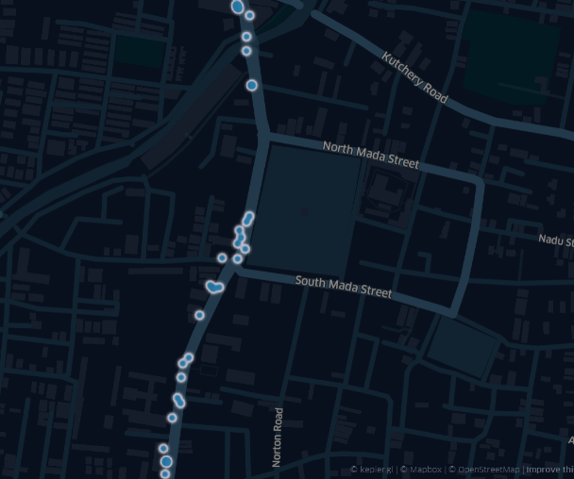 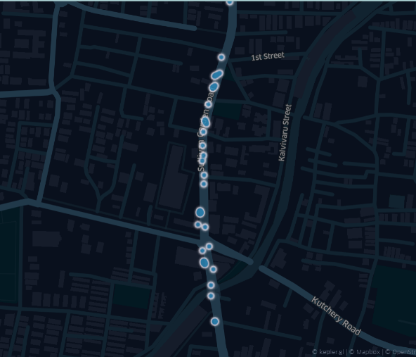

(a). Kapaleeshwar Temple Junction (b). Mayilam Local Railway Station

**Temporal Trends and Real-time Factors:**

1. Peak Pedestrian Hours: PCW alerts surge during specific timeframes, such as between 3 pm and 7 pm. This aligns with peak hours when schools, colleges, and offices close, leading to an influx of pedestrians in the area.
2. Lack of Traffic Management: Areas with inadequate traffic management, where pedestrian crossings or signals are absent or ineffective, are more likely to generate PCW alerts. These alerts act as a critical warning system in areas where pedestrian safety measures are lacking.

**Real-time Insights and ADAS Optimization:**

Understanding the spatial patterns and factors behind LDW alerts is instrumental in optimizing ADAS systems. By tailoring LDW algorithms to provide more timely and context-aware warnings in high-risk areas like complex intersections and bridges, we can enhance their effectiveness. Moreover, real-time monitoring of LDW alerts can be used to identify areas requiring improved signage, road design, or traffic management, contributing to overall road safety. Also ,LDW alerts are not just data points but crucial indicators of potential safety risks on the road. By dissecting their occurrence and understanding the contributing factors, we can make informed decisions to improve driver safety and the performance of ADAS systems. Also, PCW alerts are not just data points but vital indicators of potential pedestrian-related safety hazards on the road. By analyzing their occurrence and the contributing factors, we can make informed decisions to improve driver safety and pedestrian protection through the refinement of ADAS systems and enhanced urban planning.

**REFERENCES:**

scribd.com: <https://www.scribd.com/document/439663717/BlackSpots-169-85-64-44-Det2019>

For Tamilnadu Blackspots locations in the years of 2013,2014,2015

TNSTA: https://www.slideshare.net/MuraliD1/blackspots-in-tamil-nadu

We encourage visitors to peruse our thorough dataset visualisations on GitHub. These visual representations give users a more in-depth and engaging look at the data, which improves comprehension of the patterns, trends, and insights covered in this study. The visualisations are accessible through the following GitHub link: <https://github.com/krishnakanth22/INTEL-UNNATI-2023.git>